Student Name: Muhammad Qasim Ashfaq

Roll Number: SU92-BSAIM-S25-030

Section: BSAI-3A

LAB TASK 12
- Data Preprocessing
- Data Cleaning , Filling Null Values
- Model Training
- Saving the model using Joblib
- Creating Application

Libraries:
- pandas
- numpy
- scikit-learn
- joblib

Introduction
This is a Student GPA Prediction Dataset , this task is a continuation of Lab Task 10 and Lab Task 11 where I covered (Data Exploration, Descriptive Statistics and Data Cleaning)
In this task , I’ve used the Cleaned Dataset and trained a ML based model on this Data.

Training:
For training , I used a module named “scikit-learn” and imported Linear_Model from it. Also, I’ve used Linear Regression Model as the basis for prediction of Student’s GPA.
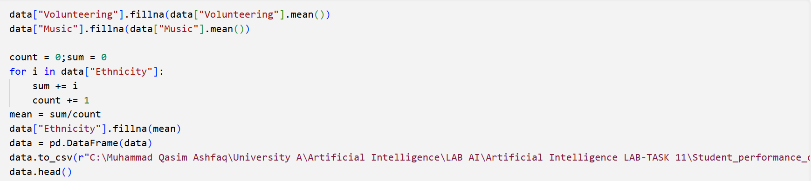
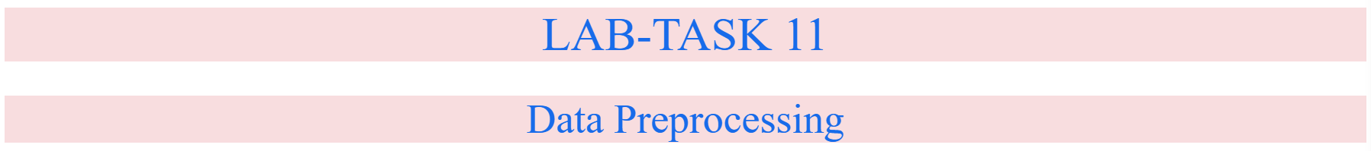
First , I filled the null values in the “Volunteering” column with the mean() value of that column and then for the “Music” column.
Just for reference I’ve used a for loop to find the mean value of “Ethnicity” column.
Then this mode value was embedded in the dataset and then new dataset was converted to a DataFrame. Which in turn gets saved to the default location using pandas pd.to_csv(path) function.
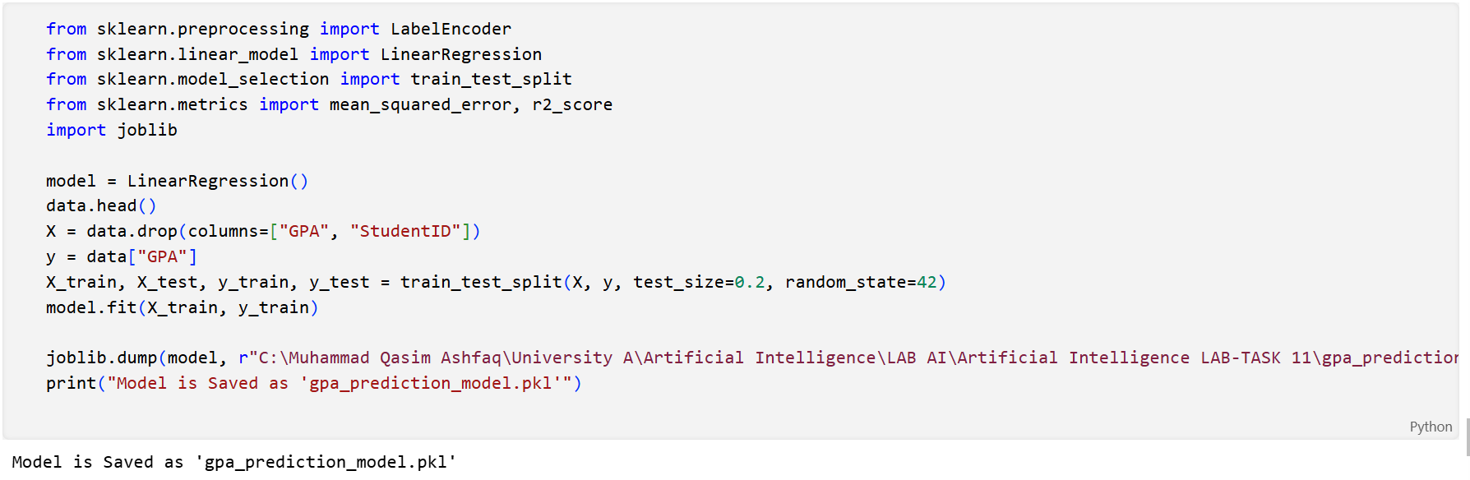
“path” defines the directory address where the csv file is present (the new file is also in the same directory as the original data file)

Linear Regression:
Linear regression is a supervised machine learning algorithm and statistical method used to predict a continuous, dependent variable based on one or more independent predictor variables.
For Prediction of any one aspect out of all the features of the Dataset , we can use Random Forest as well as Linear Regression.
Random Forest technically uses Linear Regression too but not in the direct way , it indirectly does the job.
“y = mX + b”
y is the dependent variable that is to be predicted. X is the independent variable and b is the intercept.
In the code snapshot above, model is defined as model = Linear_Regression()
X_train , X_test , y_train , y_test = (X , y , test_size = 0.2 , random_state = 42)
80 percent data is reserved for training while 20 percent is for testing purposes.
Random_State = 42 is the amount of time the data rows are shuffled before the model starts training. Its not necessary to write the value of Random_State as 42 . Its just a convention based on Hitch Hiker’s Guide to the Galaxy Book where he built a super computer to find the secrets of universe and years after the processing , it showed the result 42 .
“model.fit(X_train,y_train)”
This function (fit) is used to Feed data into the Linear Regression Algorithm of sklearn (or scikit-learn) module.

Joblib:
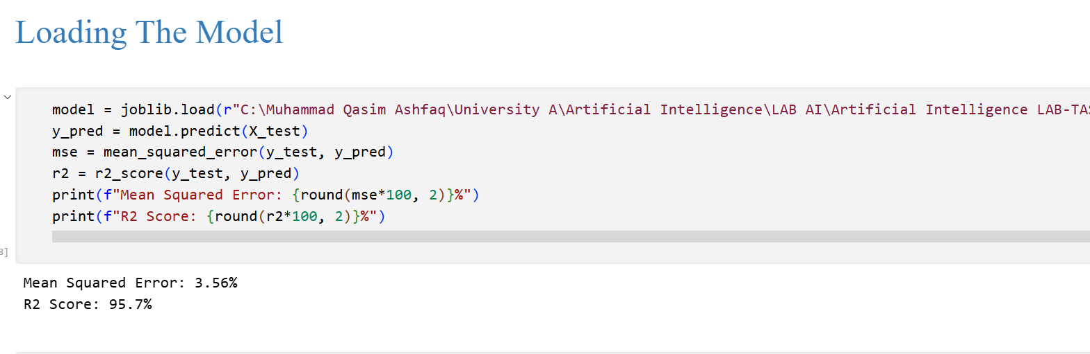
Joblib is a module that is used to optimize scientific computing and Machine Learning Processes as it uses cache storage to save the trained model in local cache, so we don’t have to use it every single time the model runs and starts to predict.
The model is then Loaded directly using Joblib after being dumped in cache previously. The Model Shows an R2 Score of 96% meaning that the accuracy is high.
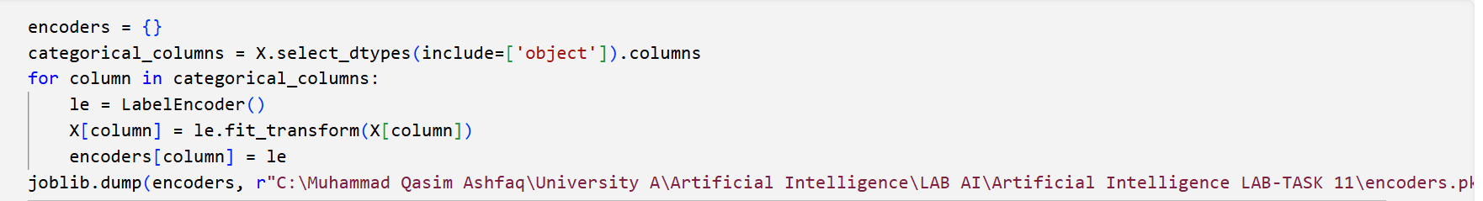
Mean Squared Error being just under 4 % shows that model can be entrusted for prediction related tasks.

Encoders are also dumped using Joblib (Pickle is also used for this purpose but I have used Joblib)
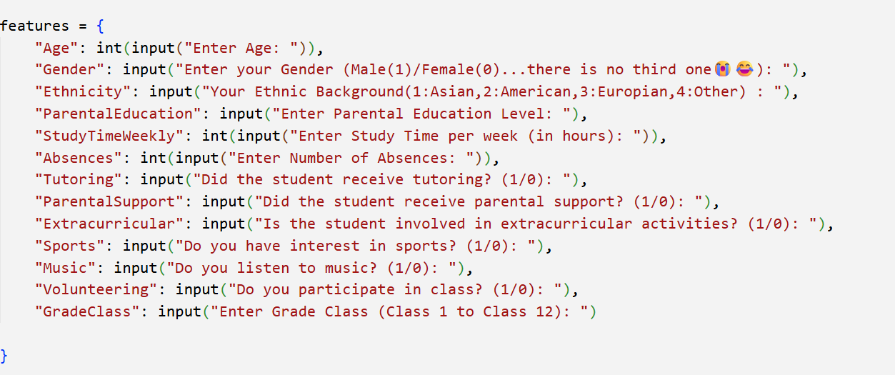
User Input is taken inside a Dictionary named ‘Features’ which include all the columns of our Dataset in chronological order (Asaan Bhaasha mai Ascending Order)
Step 2: The encoders as well as the Input Data that we took from the user in “Features” are passed to a function “encode_user_input” which encodes the inputs (if required) . In my case the data is already in Integer and Float Formats. But for OCD purposes I’ve included it here.
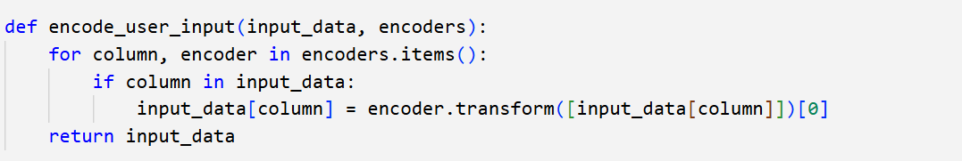
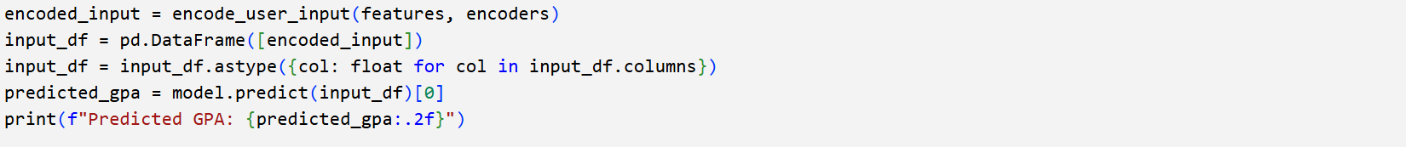
Step 3: Run the model using these Encoded Values and Print the Results

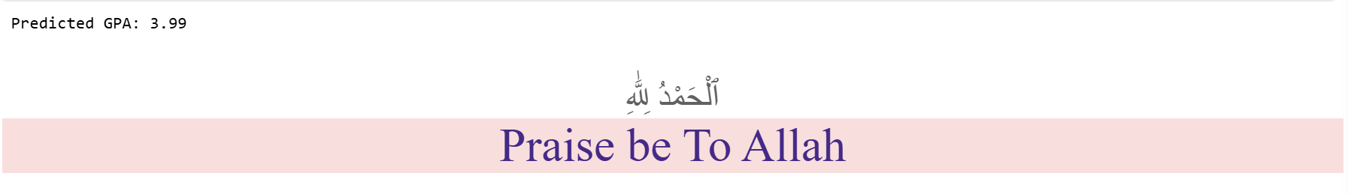
Output :

